Specifications:

TECDIS 2424
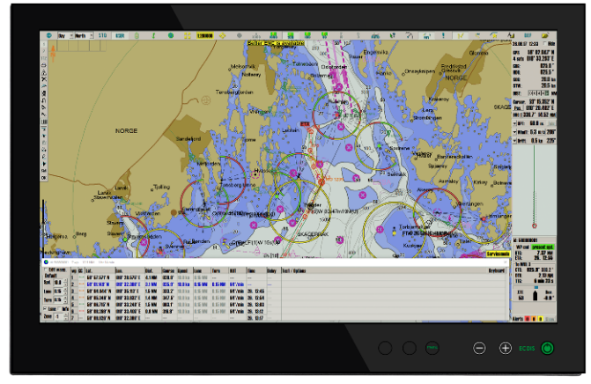

TECDIS 2424 is an all-in one ECDIS computer.
It is type-approved according to IMO regulations, allowing paperless navigation.
The integrated design makes it perfect for retrofit installation.

Standards compliance
TECDIS 2424 conforms to the following standards:
Marine Equipment Directive 2014/90/EU of the EC council.
Regulation (EU) 2018/773: | Item No. MED/4.30
SOLAS 74 as amended | Regulations V/18, V/19 & X/3
IMO Resolutions | A.694(17)  MSC.36(63)  MSC.97(73)  MSC.191(79)  MSC.232(82)  MSC.302(87)
IMO Circulars | MSC.1/Circ 1503
IEC Standards | Performance testing – IEC 61174 (2015)  Performance testing, presentation – IEC 62288 (2014)  Environmental testing – IEC 60945 (2002)  Serial interface testing – IEC 61162 (2010)

General specifications
Usable Charts | S-57 ed.3  S-63 (including Primar and AVCS)  CM-93/3 (C-Map ENC / ENC+ / CAES / Professional+)
Display | 24-inch TFT LED display with Full HD resolution. Integrated in the unit.
Operating system | Windows 7 32-bit, English
Processor | Intel Celeron P4505 – 1.86Ghz
Chipset | Intel BD82QM57
Memory (RAM) | 2 GB
Storage | 80 GB SSD (approximately 50GB free)

Display of data
Own Ship: | GPS Position, COG, HDG, SOG, STW
Route: | Active route name, DTG, ETA, and CTS-, DTG-, TTG to selected WP
ARPA targets: | BRG, DIST, COG, SOG, POS  User selectable: ARPA Target color, ARPA target track color, «Save» ARPA target track.
Others: | EBL, VRM, EBL list, Parallel index lines, Cursor position, True or relative cursor bearing
Maritime Calculation | Can calculate Range/Bearing to or from a position, with Rhumb-line or Great Circle routes, distances selectable in meters or NM.  TTG, ETA, datum conversion
Route navigation monitoring | Off track, Waypoint, Arrival, Grounding, Depth
Alarms | Off track, Index Lane, Channel limit, Waypoint approach, Depth, Non ENC dangers, Restricted Areas, Cautions Areas, Possible danger, Harbour Mode
Other Functions | Single click chart update, Night/Day presentation, ARPA-/radar target and -bearing display #1, ARPA-/radar target and -bearing display #2, MOB, SAR, Log book w/replay functionality, docking Conning display, Tooltip, User defined chart presentation, easy transfer of installed configuration to replacement cold standby unit, easy screen dump facility when in navigation mode.

Other features
Autopilot output | Output of: APB, RMB, RMC,RTE
Presentation Modes | Type approval for installation with Raytheon Anschütz NP 5500 autopilot
Radar Overlay (option) | Display of radar echoes from any Furuno radar
Seismic streamers (option) | Streamer configuration with up to 24 streamers displayed graphically in chart.
1-click chart loading | Available for charts from the following providers:  Navtor, ChartCo, Nautisk Forlag
Navtex (option) | Connects to all Navtex receivers sending in the NRX format. You can display navtex messages with position references.
Weather overlay (option) | Advanced weather overlay feature using top quality commercial maritime weather forecast data available as a subscription service from C-Map.
Piracy overlay (option) | Piracy Information is available as an overlay on top of C-MAP charts in OceanView. The C-Map OceanView navigation planning tool visualizes information to help navigators and operators identify, understand and manage risks posed by maritime crime.
AIO overlay | Show Temporary and Preliminary Notices as an overlay on the chart, with the Admiralty Information Overlay (AIO) service by UKHO.

HW Connections
No. of serial ports | 1x RS 232 (non-isolated)  1x RS422/485 (non-isolated)  4x NMEA RS422 (with phoenix 5-pin connectors)
Monitor | 1x DVI and 1 ea. VGA (DB15F)
Ethernet | 2x 10/100Mbps (RJ-45)
USB ports | 3x USB 2.0 ports  1x USB 1.1 port
Keyboard port | 1x PS/2 (Standard PS/2 mini DIN connector)
Audio ports | 1x Mic. in (3.5mm jack)  1x Line in (3.5mm jack)  1x Line out (3.5mm jack)
Port description |  | IP | IEC 61162-1 Ed 4.0 | Proprietary
Sensor | Sentences
Position 1: | GNS, GGA, GLL, RMC
Position 2: | GNS, GGA, GLL, RMC, VDO
COG/SOG1: | VTG, RMC, OSD, VDO
COG/SOG1: | VTG, RMC, OSD, VDO
Heading 1: | HDT, OSD, VHW, VDO, THS
Heading 2: | HDT, OSD, VHW, VDO, THS
Water speed: | VHW, OSD, VBW
Radar ARPA 1: | TTM
Radar ARPA 2: | TTM
Radar cursor 1: | RSD
Radar cursor 2: | RSD
AIS (In- and output): | AIxxx
Depth: | DPT, DBT
Rel. wind: | MWV
Route: | WPL + RTE
Alarm ctrl. (In- and output) | ALR + ACK
Navtex | NRX
Search | FLIR
Option 1
Option 2
Option 3
Option 4
Printer: | USB port printer connection only

Power Supply
Power supply | Multipower - 115 to 230 VAC, 50 ~ 60 Hz + 24 VDC
Power cons. max | 125W
Power cons. typ. | 50W

Equipment List

Standard
- Computer, HD 24T21 MEC or EEC
- TECDIS code plug
- Accessories Box
  - TECDIS Installation Manual
  - TECDIS User Guide
  - USB extension cable 1.0m
  - CD-bag
    - Driver CD from Hatteland
    - Chart database DVD C-Map Professional+
    - Chart database DVD C-Map CAES
    - TECDIS Service Key (USB memory stick)
  - AC power cables 220 VAC/50Hz euro type F and 115 VAC/60Hz US type B power cable
- Cherry G84-4100LCMGB-2, keyboard
- Logitech TrackMan Marble ELK, mouse
- Declaration of Conformity

Options
- Mounting brackets incl. screws for console mount
- Mounting brackets incl. screws for table mount
- External CD/DVD-drive via USB
- Telko Alarm Interface TEA-01
- Navtex, TECDIS SW option programmed in code plug
- Weather overlay, TECDIS SW option programmed in code plug
- Piracy overlay, TECDIS SW option programmed in code plug

Document revision history
1.0 | 22nd August 2013 | Initial release | Cato Haugland
2.0 | 04th January 2018 | Second release. Completely rewritten. | Cato Haugland
3.0 | 20th August 2018 | Third release. Updated technical drawing presentation and template design. | Cato Haugland

Paperless navigation requires a dual ECDIS installation.
C-Map Professional+ is not an official chart service, it does however provide world scale charts

